# Create a Content Specialist AI Agent in **Make.com**

Follow the steps below to build an AI agent that finds the latest AI news, turns it into an Instagram reel script + LinkedIn post, generates an image, and emails everything to you each day.

**Overview**

This guide walks you through creating a Make.com scenario (workflow) and an AI Agent that:

* Searches the web for the most important AI news (recent launch/announcement)
* Parses the result (title, summary, URL) as structured JSON
* Uses a large language model (e.g., Gemini) to generate:
  + A 150‑word Instagram reel script
  + A LinkedIn post (caption) in a clean format
* Generates a single representative word for an image and uses an image model to create the image
* Emails the HTML output (script + post) with the image attached
* Runs automatically on a schedule (e.g., daily at 11:00 AM)

**Prerequisites**

1. **Make.com account** (free plan is fine to get started)
2. **An LLM-based news/search provider** account (Perplexity or Open AI Assistant a similar web-aware LLM) and its API key
3. **Generative LLM account** (for text + images) — the video uses Gemini (AI Studio) or any other model with text/image APIs
4. **Gmail account** (or other email service connected to Make) to send emails

**Quick architecture (high level)**

Trigger (Webhook) → News search module (Perplexity) → JSON parser → Gemini text completion (script + LinkedIn) → Gemini single-word extractor → Gemini Image generation → Gmail (send email with HTML + image attachment)

**Detailed Steps**

Each numbered step corresponds to a module or action in Make.com. Read the whole step first, then follow it in Make.com.

**1. Create the scenario & trigger**

1. Log into **Make.com** → go to **Scenarios** → **Create a new scenario**.
2. For the trigger, add the **Webhooks** module → choose **Custom webhook** → **Add a webhook**.
3. Name it (example: content-generator-webhook) and **Save**. Copy the webhook URL — you’ll use this to run/test the scenario.

Tip: During testing, open the webhook URL in your browser to trigger a run (or use Make’s test/run button).

**2. Add a news-search module (Perplexity or similar)**

1. Click the **+** to add a module after the webhook.
2. Search for your news/search LLM (the video used Perplexity). Choose a module like **Create a Chat Completion** (or equivalent) for that service.
3. **Connect** the module using the API key (obtain from the provider’s dashboard).
4. Choose the news-search model (video used sonar / sonar-pro as an example). Use whatever the provider recommends for web search.
5. **Prompt** (example) — set role = user and paste this prompt (modify timeframe as needed):

Find and analyze the most important AI tool or product that was launched in the last 4-5 days.

Your goal is to summarize it in plain language based on reputable sources.

Respond only in valid JSON with these fields: title, summary, url.

Example:

{

"title": "...",

"summary": "...",

"url": "https://..."

}

1. Save the module and run a test to ensure it returns a JSON-like string or a search payload containing the best source.

**3. Wrap results as JSON and parse**

1. If the news module returns a free-text output, add **Tools → Compose a string** (or similar) to wrap the output inside braces or build a JSON string.
2. Add a **JSON** (Parse) module to convert the JSON string into separate fields: title, summary, url.
3. Configure the JSON parser to create three outputs (all text) so downstream modules can reference them as variables.

**Sample parsed JSON structure**

{

"title": "New AI Summarizer 3.0",

"summary": "A plain-language summary of what the tool does and why it matters.",

"url": "https://example.com/article"

}

**4. Add the LLM module to create your reel script + LinkedIn post (Gemini or other)**

1. Add a **Create a Chat Completion** module (Gemini / your text model).
2. Connect with the model API key and pick a fast/high-quality model (the video used Gemini 2.5 flash).
3. In the module, set up a message with the **role: user** and provide a long prompt that:
   * Tells the model to act as a top-tier content strategist
   * Supplies the {{title}}, {{summary}}, and {{url}} variables (use Make’s variable picker)
   * Requests output in HTML for email
   * Requests the Instagram reel script (150 words) and the LinkedIn post (format rules)

**Example prompt (paste into the module)**

Act like a top-tier content strategist. Below is today's top AI news.

Title: {{title}}

URL: {{url}}

Summary: {{summary}}

Task 1: Write a 150‑word Instagram reel script in the style of a clear, casual tech explainer. Start with a bold hook, explain what happened, and end with a call to action.

Task 2: Write a LinkedIn post that summarizes the news and ends with a question. Use a short, curiosity-building oneliner as a header.

Return the result in clean HTML using this structure:

<h2>{{title}}</h2>

<h3>Instagram reel</h3>

<p><!-- reel script here --></p>

<h3>LinkedIn post</h3>

<p><!-- linkedIn caption here --></p>

Respond only with the HTML.

1. Save and run the module to verify that the model returns the requested HTML output.

**5. Extract a single keyword for the image**

1. Add another text completion module that **returns just one word** (the central topic/keyword to put on the image).
2. Prompt example:

Based on this news summary: {{summary}} return the single most important word that best represents the topic. Return only one word, lowercase.

1. Save and test.

**6. Create the image (Image generation module)**

1. Add the provider’s **Create Image** module (the video used Gemini Image Gen 3.0).
2. Configure the size/aspect ratio (the video used 1:1) and any content allowance flags.
3. Build an image prompt that uses the single word and a style. Example prompt for a LEGO style image:

A high-quality 1:1 LEGO-style scene: a person working on a laptop with the word "{{keyword}}" bolded on the t-shirt and on the laptop screen; bright, modern, professional composition; shallow depth of field; pleasant studio lighting.

1. Save and test the image generation. Set the module to output the image file for use as an attachment.

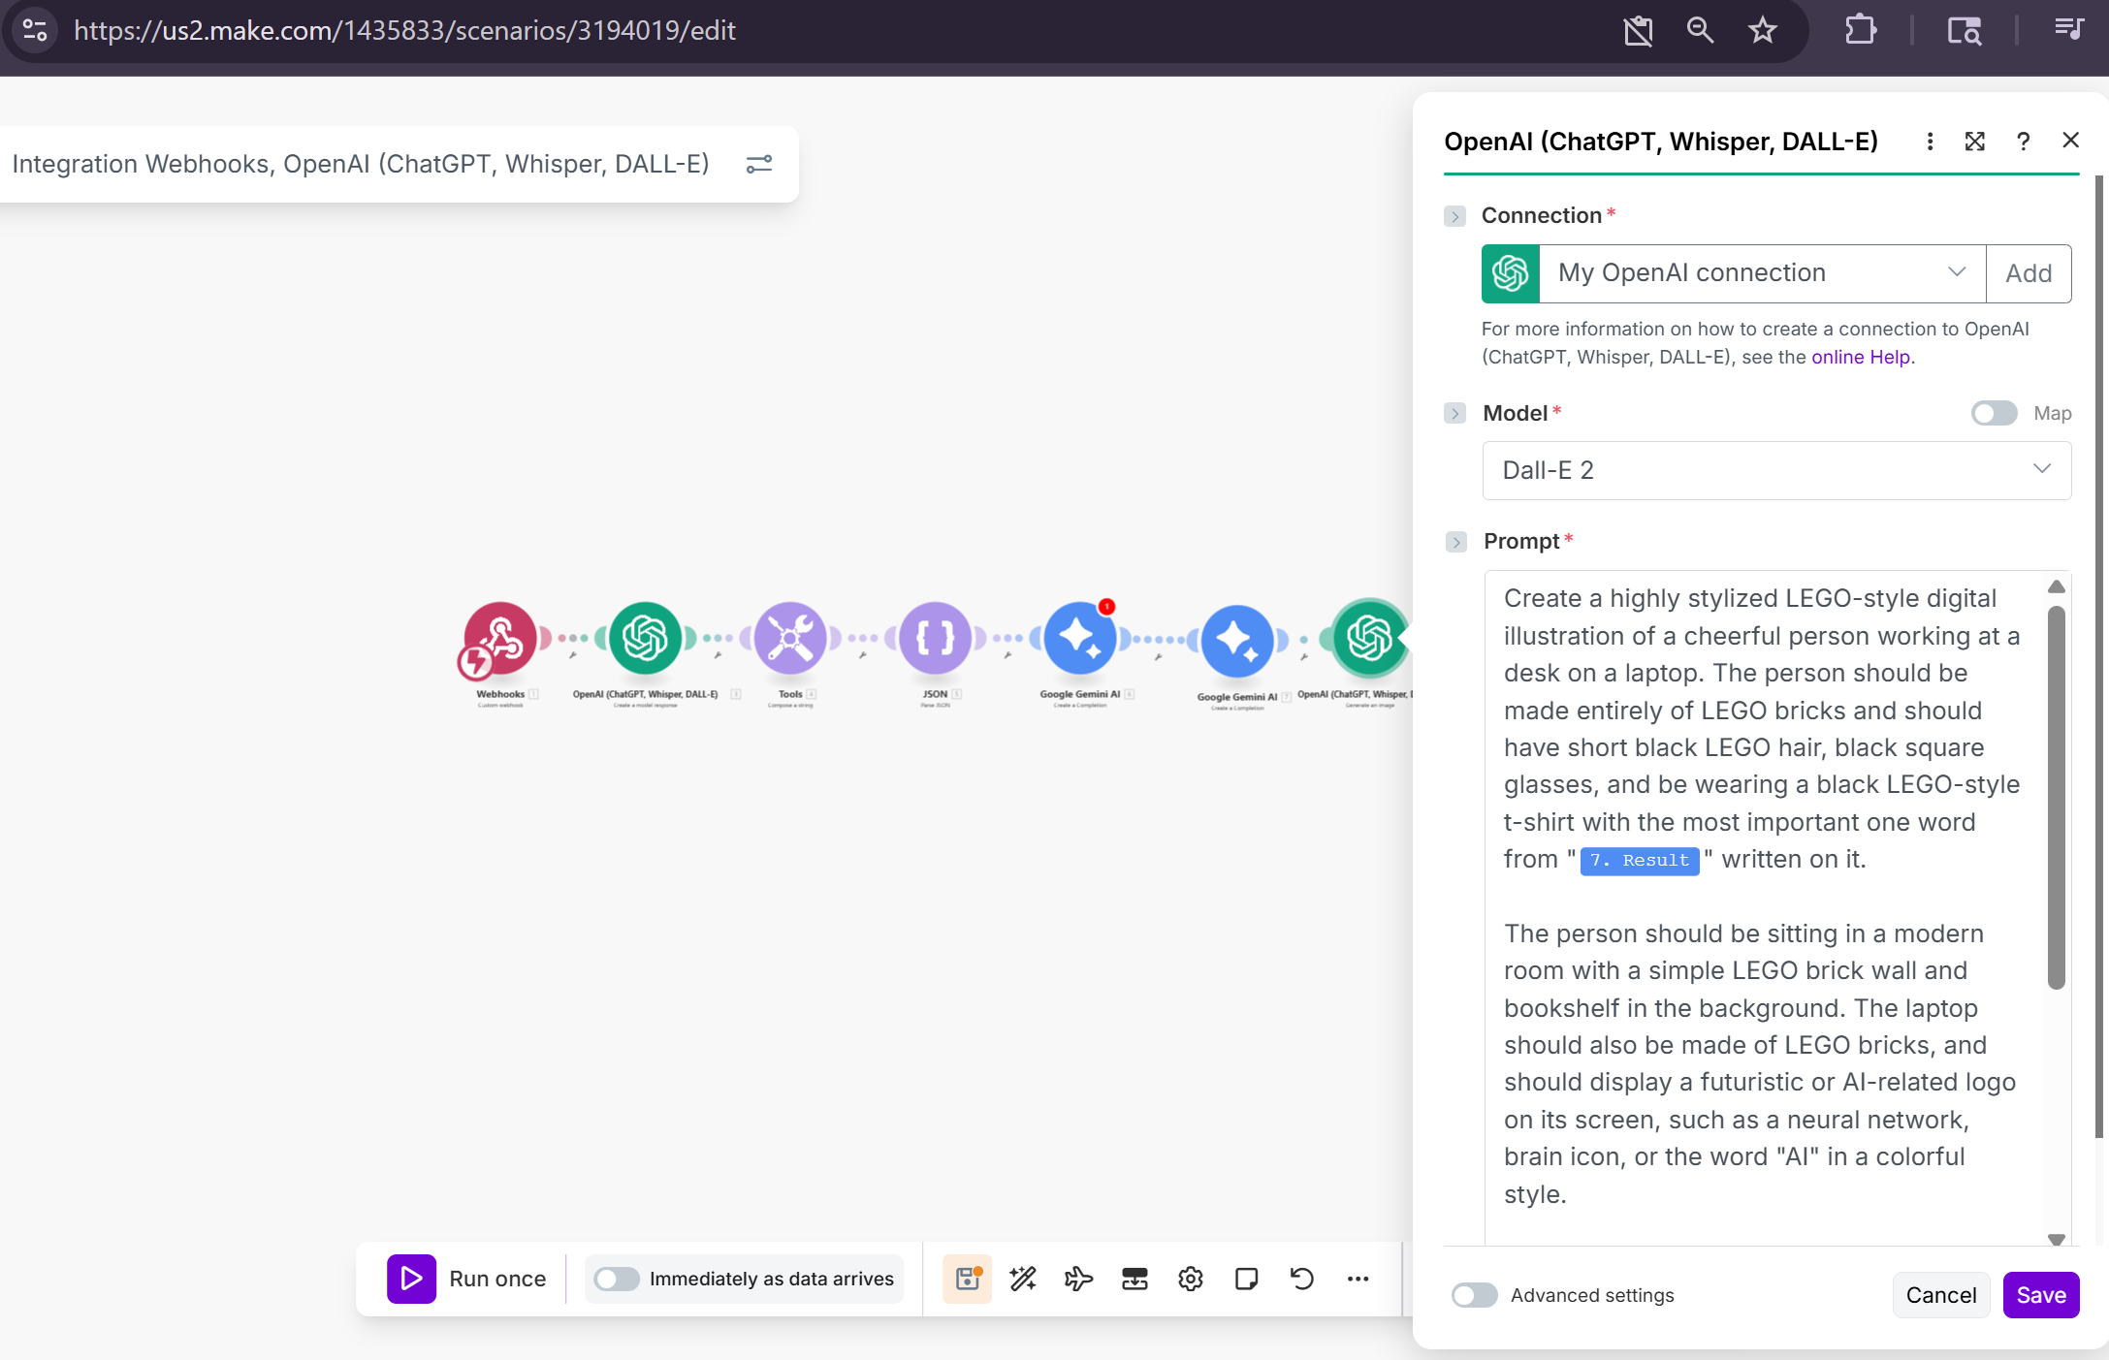

**7. Send the results via email (Gmail module)**

1. Add **Gmail → Send an email** module (or use another email provider module).
2. Connect your email account (authorise Make to send on your behalf).
3. Configure fields:
   * **To:** your email address
   * **Subject:** use the Gemini title/output variable (e.g., Today's top AI news: {{title}})
   * **Body:** insert the HTML returned by the Gemini text module (use the variable picker to place the HTML) — make sure the Gmail module supports HTML body.
   * **Attachments:** choose the image output from the image module. Set a content ID like AI_IMAGE if you want the image inline.

**If you want the image inline:**

* In the email body reference the image with an inline CID: <img src="cid:AI_IMAGE" alt="AI image"> and set the attachment content ID to AI_IMAGE in the attachment mapping.

1. Save and run the whole scenario to verify the mail arrives with the HTML and the image.

**8. Test the entire flow**

1. Click **Save** and then **Run once** in Make.
2. Trigger the webhook (open the webhook URL in a browser or trigger via an HTTP request).
3. Inspect the execution results for each module:
   * Confirm Perplexity output contains title, summary, url.
   * Confirm the Gemini text completion returned HTML that matches your expected format.
   * Confirm image module returned a file.
   * Confirm Gmail module shows successful send.
4. If a module fails, click into it in Make and examine the error message and raw output for debugging.

**9. Convert the scenario into a reusable Make AI Agent**

1. In Make, go to **Make AI Agents** → **Create a new agent**.
2. Name it (e.g., Content Specialist).

